Category: Hard

Competition: CSI KJSCE Code Wars 2018-18. Try the question in the competition:

<https://www.hackerrank.com/contests/codewars2-round1/challenges/hills-and-depressions>

Question:

A group of geologists were observing satellite data of various regions. The satellite measured the height (positive) or depth (negative) of various points with respect to the sea-level which is taken as 0. They had thousands of terrain entries and wanted to classify them as hills, depressions or neither. A hill could be identified as any region that has only a single peak which may cover a large area whereas a depression is a region that has a single bottom(minima) point which again may cover a large area (All depressions will be below sea level at all points). Given a 2D 7X7 height matrix representing heights of points on the surface (which is now represented by a matrix), classify the region and also state the area of the peak in terms of number of array elements it covers. Form of the matrix:

0 0 0 0 0 0 0

0 a11 a12 a13 a14 a15 0

0 a21 a22 a23 a24 a25 0

0 a31 a32 a33 a34 a35 0

0 a41 a42 a43 a44 a45 0

0 a51 a52 a53 a54 a55 0

0 0 0 0 0 0 0

The 0s represent the region being bounded by sea-level. If the 5X5 matrix represented by the aij is entered, classify the region into H,D,N:   
H for Hill D for Depression N for neither Contours representing the features:

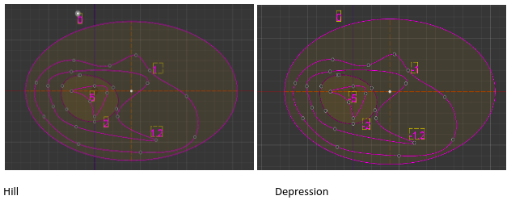

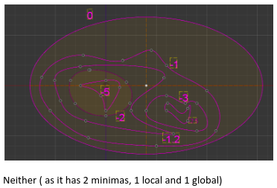

**Input Format**

A 5x5 matrix representing altitudes (aij)

**Constraints**

-109 ≤ aij ≤ 109 ϵ R

**Output Format**

Print ‘H’ or 'D' followed by space followed by integer denoting area of Hill or Depression respectively. Print 'N' if it is neither Hill nor Depression.

Examples:

10 20 25 40 35

30 50 41 50 45

33 50 50 30 12

45 34 20 10 5

1 2 3 4 6

H 4

The given figure has single maxima of height 50 which extends an area of 4 units.

10 20 25 40 35

30 35 41 50 45

33 34 20 30 12

45 50 50 10 5

1 2 3 4 6

N

The given figure has 2 maxima so it is neither

Try these inputs:

|  |  |
| --- | --- |
| **Input** | **Output** |
| 0.1 0.2 0.3 0.4 0.5  1.0 0.9 0.8 0.7 0.6  1.1 1.2 1.3 1.4 1.5  1.6 1.7 1.8 1.9 2.0  2.5 2.4 2.3 2.2 2.1 | H 1 |
| 35 4 3 2 1  10 20 30 40 50  1 2 3 4 5  0.5 1 1.5 2 2.5  0.25 0.5 0.75 1 1.25 | N |
| -0.1 -0.2 -0.3 -0.4 -0.5  -1.0 -0.9 -0.8 -0.7 -0.6  -1.1 -1.2 -1.3 -1.4 -1.5  -1.6 -1.7 -1.8 -1.9 -2.0  -2.5 -2.4 -2.3 -2.2 -2.1 | D 1 |
| 1 1.3 1.2 1.1 1  1.2 1.4 1 0.5 0.1  1 1.5 1.7 1.7 1  0.5 0.41 1.7 0.21 0.1  0.4 0.3 0.2 0.1 0.05  0.02 0.04 0.06 0.08 0.09 | H 3 |
| 1 2 1 2 1  2 1 2 1 2  1 2 1 2 1  2 1 2 1 2  1 2 1 2 1 | H 12 |
| 1 1 1 1 1  1 0 0 0 1  1 0 1 0 1  1 0 0 0 1  1 1 1 1 1 | N |
| 1 1 1 1 1  1 0 0 0 1  1 0 0 0 1  1 0 0 0 1  1 1 1 1 1 | H 16 |
| 1 1 1 1 1  0 0 1 0 0  0 0 1 0 0  1 1 1 1 1  0 0 0 0 2 | H 1 |